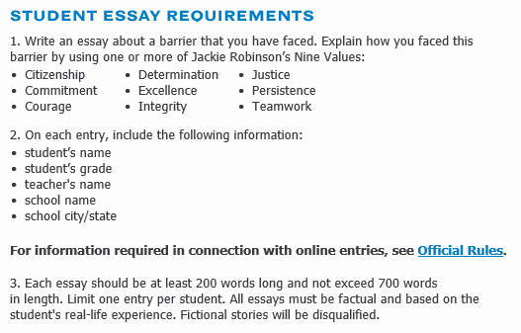

http://www.scholastic.com/browse/article.jsp?id=3755328

