Subject: Music & Art

Conflict in Art: An Unlikely Muse

Aim / Essential Question
How does conflict inspire meaningful music and other lasting art?

Overview
During times of violent conflict and cultural oppression, music and art take on a deeper meaning and enduring significance. In this lesson students will examine the role of conflict in art by comparing the “Star-Spangled Banner” and “Ilus maa/Beautiful Land” from The Singing Revolution.

Objectives
- Recognize and explain the role of conflict in various examples of art.
- Compare and contrast two patriotic songs inspired by conflict.
- Distinguish and list lyrics which relate to conflict.

The Role of Conflict in Art

1. Look at an image of Pablo Picasso’s “Guernica” painting.
http://www.pablopicasso.org/guernica.jsp#prettyPhoto[image2]/0/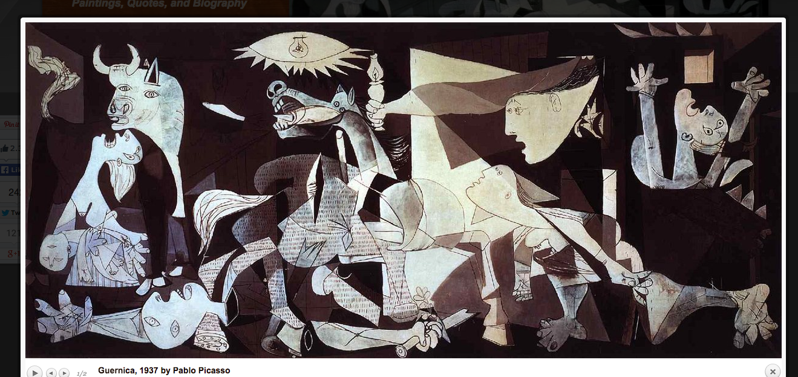
- What individual images do you see in Picasso’s “Guernica?” List three or more.

- What do you think Picasso’s message or theme was in painting “Guernica?”

Read the lyrics to Francis Scott Key’s “The Star-Spangled Banner.” (below)
Answer the following:

3. What words and phrases indicate that this song was inspired by conflict?

4. What role did conflict have in the creation of this song?

5. Why is this song so powerful to the American people?

Read the lyrics to “Ilus maa/Beautiful Land.” (below) Answer the following:

6. What words and phrases indicate that this song was inspired by conflict?

7. What role did conflict have in the creation of this song?

8. Why is this song so powerful to the Estonian people?

Directions: In the following chart, compare and contrast “The Star-Spangled Banner” with “Ilus maa/Beautiful Land.” List similarities on the “Compare” side and differences on the “Contrast” side.

Compare | Contrast

What role does conflict have in inspiring lasting art? Answer in several thoughtful sentences.

The Star-Spangled Banner Lyrics
By Francis Scott Key — 1814

Oh, say can you see by the dawn's early light
What so proudly we hailed at the twilight's last gleaming?
Whose broad stripes and bright stars thru the perilous fight,
O'er the ramparts we watched were so gallantly streaming?
And the rocket's red glare, the bombs bursting in air,
Gave proof through the night that our flag was still there.
Oh, say does that star-spangled banner yet wave
O'er the land of the free and the home of the brave?
On the shore, dimly seen through the mists of the deep,
Where the foe's haughty host in dread silence reposes,
What is that which the breeze, o'er the towering steep,
As it fitfully blows, half conceals, half discloses?
Now it catches the gleam of the morning's first beam,
In full glory reflected now shines in the stream:
'Tis the star-spangled banner! Oh long may it wave
O'er the land of the free and the home of the brave!
And where is that band who so vauntingly swore
That the havoc of war and the battle's confusion,
A home and a country should leave us no more!
Their blood has washed out their foul footsteps' pollution.
No refuge could save the hireling and slave
From the terror of flight, or the gloom of the grave:
And the star-spangled banner in triumph doth wave
O'er the land of the free and the home of the brave!
Oh! thus be it ever, when freemen shall stand
Between their loved home and the war's desolation!
Blest with victory and peace, may the heav'n rescued land
Praise the Power that hath made and preserved us a nation.
Then conquer we must, when our cause it is just,
And this be our motto: "In God is our trust."
And the star-spangled banner in triumph shall wave
O'er the land of the free and the home of the brave!

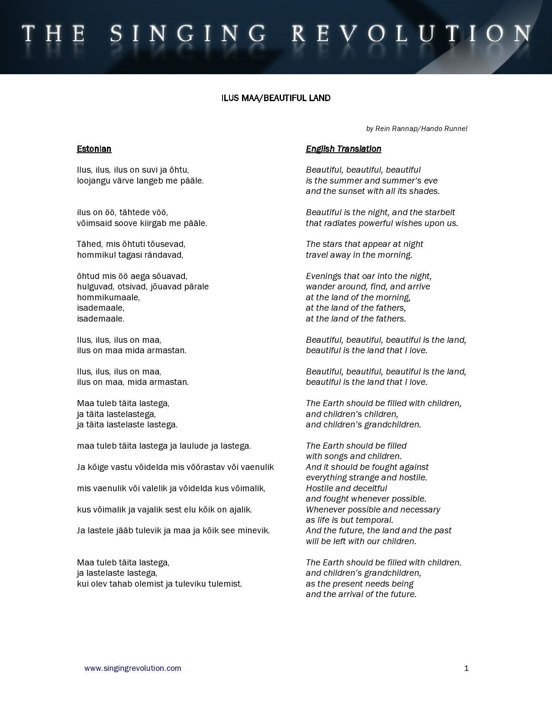

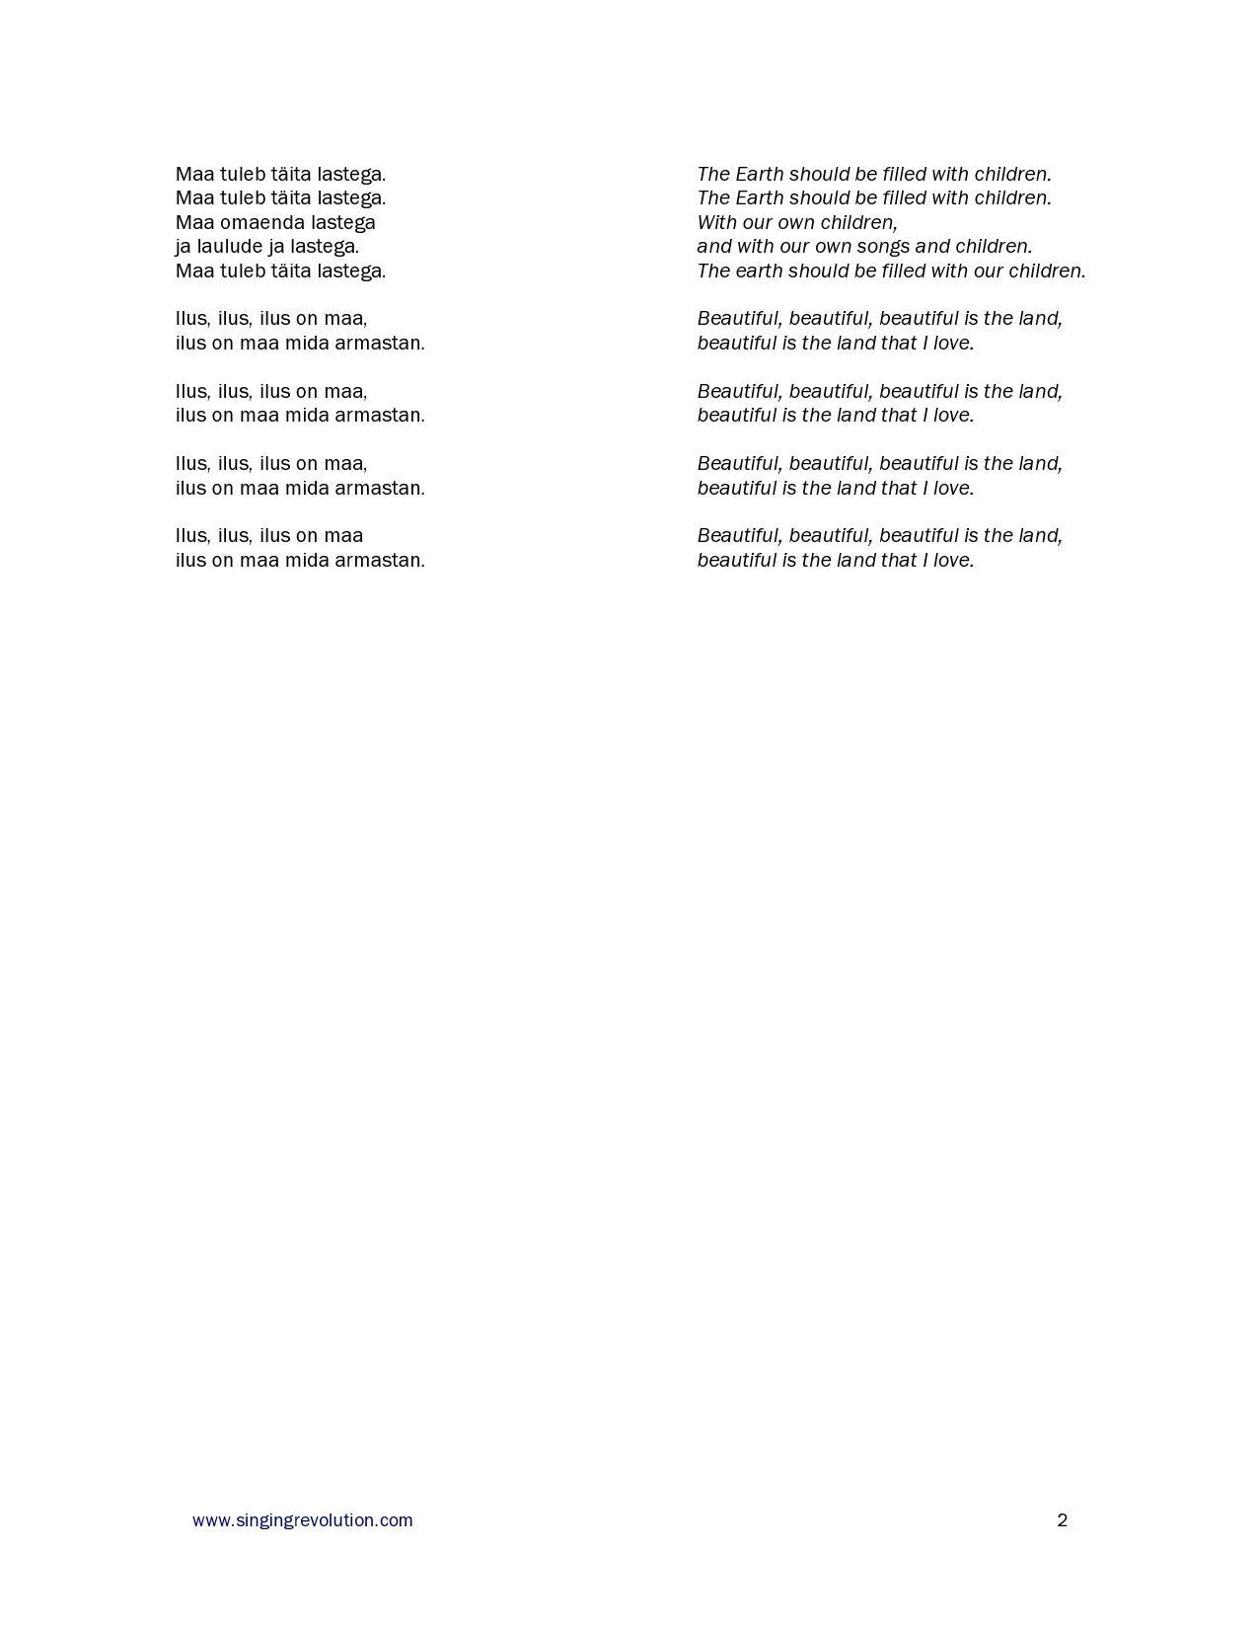

3-2-1 Summarizer

List three pieces of art (from class) which were inspired by conflict:

1.

2.

3.

List two reasons why conflict contributes to meaningful art:

1.

2.

Research. Find one other piece of art (song, statue, painting, sculpture, etc.) which was inspired by conflict. Explain the history and meaning of this piece.

