The Meaning in the Music: Emotional Connections

Aim / Essential Question
How does music inspire emotional response from an audience?

Overview
Composers and artists often write to capture a certain emotional perspective. In classical and orchestral music, the conductor helps communicate these emotions to the musicians, and, in turn, the audience. This lesson will consider how music can convey emotion, as students examine a clip and lyrics from The Singing Revolution.

Objectives
- Listen to several examples of music and associate emotional words and phrases.
- Compare associated emotional words with the lyrics of “Ilus Maa/Beautiful Land.”
- Evaluate the benefits of major vs. minor keys, and the differences in the emotions each conveys.
- Discuss the emotions conveyed through gestures, facial expressions, and harmonies along with the music and lyrics.

Task 1
Word Association Chart

- Listen to the theme song for Back to the Future played by an orchestra in Vienna. In the box below, list 5 (or more) words or short phrases which relate to how you feel during while listening to the song.

- Listen to “Ilus Maa”/Beautiful Land.” In the boxes below, list words and phrases which relate to how you feel during the three sections. Pay attention not only to the music but also to the gestures and motions of the conductor, as well as the facial expressions of the various singers.
  - The three sections are distinguished by their key changes.

Beginning:

Middle:

End:

After reading the lyrics, answer the following questions.
Did your associated words offer any insight into why the composer would pair this music with these words? How do your words connect with the song lyrics?”

Beginning
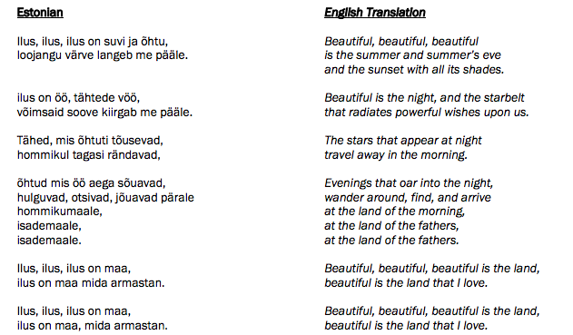
Middle
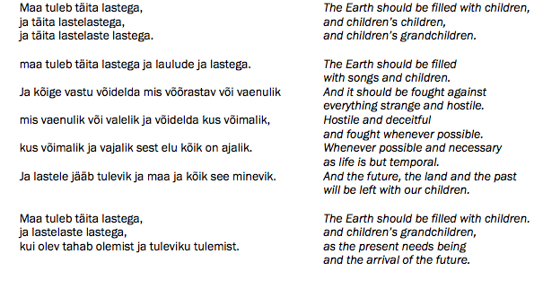

Ending

Task 2

Reflection Questions

- Why do you think the composer chose to change keys in the middle of the song, and then back to the original key at the end? What emotional effect do the changes add to the music?

- Consider the expressions of the different singers who had close ups during the video clip. What do you notice about their expressions while singing? Is there a difference between young and old singers? Can you tell what the singers are feeling? How?

- The conductor is quite animated. How can you tell that he’s emotionally connected to the music? Which of his actions most stick out in your memory? Do his mannerisms enhance the emotional effect of the music? Why or why not?

- Consider the size of the choir and how defined the harmonies are throughout the song. Does the harmony enhance the emotional power of the music? How? Is it inspiring to see so many people singing together? Why or why not?

Task 3
Select a song that holds meaning for you. After choosing this song, repeat the same steps above listening to the song and then reading the lyrics. Change the prompts/questions to fit your response.

Beginning:

Middle:

End:

After reading the lyrics, answer the following questions.
Did your associated words offer any insight into why the composer would pair this music with these words? How do your words connect with the song lyrics?”

