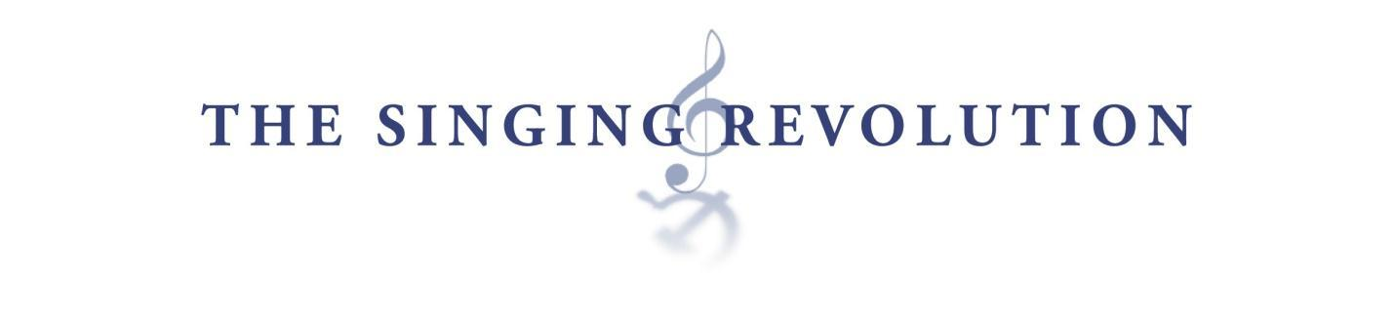Totalitarianism in George Orwell’s Animal Farm and in Estonia

Aim / Essential Question
How did the Soviets dominate Estonia and control the Estonian people?

Overview
George Orwell, in his novel Animal Farm, described the shape a totalitarian government on a farm. Napoleon employed various means to crush the individual and dominate the society at large. This lesson compares the techniques Napoleon used in Animal Farm with the techniques used by Stalin and the Soviets on the Estonians.

Objectives
- Identify totalitarian techniques of acquiring and maintaining power.
- Compare and contrast the use of totalitarian techniques in Orwell’s Animal Farm with the use of totalitarian techniques in Estonia under the Soviets.
- Connect the use of totalitarian techniques to a current situation somewhere in the world.

Written Response #1
Write a one paragraph response to the following question: To improve order at this school, which of the following actions do you think would be effective? Elaborate.
- Surveillance
- Spying
- Propaganda
- Terror
- Torture

Discussion
Share your paragraph with another member in class. Then, discuss the following questions.

- Which of the above measures are acceptable, and which are not?
- What limits the school’s ability to use more extreme measures, like torture?

Written Response #2
Complete the graphic organizer below.

Written Response #3
Answer the following questions:
  - Why did the Soviets use these techniques?
  - What was the ultimate goal?
  - Did the techniques work for the Soviets?
  - How were they effective or ineffective?

Written Response #4
Write a paragraph in response to the following question: Under Stalin, the Soviets successfully dominated Estonia, but nearly four decades after his death the Soviet regime broke down. What problems do you think a totalitarian government like the Soviet regime would face in the long term?

Written Response #5
Research a totalitarian regime that exists somewhere in the world today. Describe in depth, but not more than one page, the totalitarian techniques the government of this country practices on its people.

Comparison Chart: Animal Farm and The Singing Revolution

Totalitarianism: When a government, often controlled by a dictator or faction, recognizes no limits to its authority and seeks to maintain control over the lives of its citizens.

Directions: A totalitarian government maintains total control through various techniques. Identify three techniques. For each technique, cite an example of it being used in the novel Animal Farm by George Orwell and in the documentary film The Singing Revolution.
 | Example from Animal Farm | Example from TSR
Totalitarian Technique 1

Totalitarian Technique 2
Totalitarian Technique 3
Concluding question: How are these techniques effective for maintaining control?

